**FOLLOW-UP SUMMARY REPORT OF USER EXPERIENCES:**

**REVIEW OF THE VETERAN DELEGATION TOOL**

**Purpose and Objectives:** The purpose of this follow up summary report is to inform operation stakeholders of users’ experiences during the Veteran Delegation Tool (VDT) implementation process and highlight challenges encountered. Objectives are to: (1) Describe experiences of the participants, (2) Illustrate challenges and barriers using personalized Vignettes, and (3) Provide list of recommendations and strategies suggested to improve the Veteran Delegation Tool registration process.

**Data Sources:** Data was gathered from two sources: 1. Initial and follow-up interviews with participants that made attempt to use the VDT system; and, 2. Usability feedback from participants that tested the system with one or more of the QI team members.

**Findings:** Overall key findings and vignettes (See Appendix A) were created by QI team members that conducted and analyzed interview data (See Appendix B) went through the registration process after the initial challenges encountered during the initial review were resolved/addressed by the developer. These findings are illustrated in the following sections.

**OVERALL KEY FINDINGS**

Initial interviews were conducted with 29 Veterans and 23 selected delegates [preliminary findings were previously submitted and presented to OCC/MHV]. Follow up interviews (N=6) were conducted with 1 Veteran, 4 selected delegates and 1 healthcare provider to explore participants experience and perceived benefits of the VDT including the ability to schedule appointments, refill medication, and communicate with the healthcare provider on behalf of the Veteran’s request. Data were analyzed using rapid iterative method.

The following key findings represent themes that emerged from the rapid analysis on the follow-up 6 interviews recently conducted and the vignettes:

* VDT registration process
  + Invitation email indicates the invitee should use the link provided to accept or reject the proposed designated role as a VA Online Health Delegate (VAOHD), however, the link takes the invitee to the MHV site to establish an account if they haven’t established one in the past. This has confused many people.
  + The delegate is required to share their own PII (SSN, DOB, email, etc.) with the Veteran in order for the Vet to enter the delegation request into the system.
  + When the Veteran signs the authorization for VAOHD, it appears to require at least 3 layers of signing, before it officially accepts the signature.
  + During the registration process, it is easy to think the process has been completed, when in fact it isn’t. It is difficult to assess and identify if there is anything left to do.
* VDT Sign-in for delegate
  + Multiple options with minimum guidance (for participants or for staff) on what should be best route.
  + Many participants selected ‘MHV’ as the first choice to create a sign-in partner, because they know they’ll need a MHV account eventually. Unfortunately, MHV can only be used as a sign-in partner after it is upgraded to a Premium Account, which will require a different/existing sign-in partner.
* MHV Premium Account
  + A delegate must have a Premium MHV account, however the MHV does not provide the option of upgrade unless the user checks the ‘VA Patient’ and/or ‘Veteran’ boxes. This hindered participants from moving forward.
  + Initial information on MHV explicitly states that the Premium upgrade has to be done in-person, though in other areas, it does state it can also be done online. This also hindered participants from moving forward. Some individuals knew they’ll need to access MHV, however others didn’t understand why they need a MHV account for themselves
  + After changing profile to Veteran, the system automatically adds the account owner as a VA patient. The system then would not allow the VA patient status on the profile to be unchecked.
* VDT Use
  + Delegates are not informed of responses to secure messaging inquiries. If vet changes the preferred email address, then only the delegate will receive the notifications.
  + Providers do not have a way to ‘cc’ the secure message response to the delegate.
  + If the delegate includes a phone number in the secure message for the provider to call back- there is no clear way for the provider to confirm they are talking to the authorized delegate.
  + Some requests made through secure messaging travels through several hands (I.e. nurse, provider, unit clerk). The person fulfilling the request (I.e. scheduling an appt) does not necessarily know that they were supposed to correspond with the delegate.
  + There are multiple avenues to sign into MHV but only signing in through an established sign-in partner would grant access to the delegate account. There is no indication which sign-in method is the correct one. Delegates use trial an error method until they find the correct path.

**DATA FINDINGS VIGNETTES**

Detailed data summaries of findings and recommendations are illustrated in Appendix A. Sample:

Vignette 1: New Veteran (Jacob)

Vignette 2: Established Veteran with existing MHV and VDT (Angel)

Vignette 3: New delegate external to the VA/civilian (Monica)

Vignette 4: New delegate external to the VA/civilian but knowledgeable of the project (Tali)

Vignette 5: Healthcare Provider- end user (Carol)

Vignette 6: Administrator (TY)

**RECOMMENDATIONS FROM VIGNETTES**

The following preliminary recommendations are based on interview and vignette data as illustrated in Appendices A&B.

* Invitation email should provide step-by-step instructions about the process up front in the invitation email.
* Change up the order of what the delegate is asked to do, so that they are not registering for multiple things at the same time: 1) Register with a sign-in partner, if you don’t already have one 2) Create a MHV account 3) Upgrade to a Premium MHV account 4) Register for VDT.
* Remove any misleading communication in existing emails within the MHV and VDT sites.
* At minimum, end-users need to be able to ‘cc’ communications to the delegate, when the delegate initiates a secure message.
* Include prompts to indicate when a step is completed to alert the user of what to expect next.
* Once the miscommunications are removed and the addition of prompts are added to the VDT, then proceed with creating concise training guidelines.
* Add a section in the existing MHV Guidebook explaining the VDT registration process and provide step-by-step instructions to promote functional use.
* All administrators need access to the delegation administration sites.
* A secure method of observing the steps of registration will provide clarity in where assistance is needed
* Clear relaying of information to caregiver and Veterans for understanding of which steps they are working on and which steps have been completed

**APPENDIX A: VDT PARTICIPANT VIGNETTES**

**Vignette #1:** Veteran newly established in the VHA/VBA (Jacob)

JS has recently been discharged from a lengthy stay in a civilian hospital, followed by a lengthier inpatient rehab stay- in the midst of a pandemic. His saving grace was the willingness of 3 longtime neighbors willing to take on the responsibility. Remembering his old stories of Vietnam started the inquiries into trying to establish him with VA resources/healthcare, and to make sure the trio would be empowered to minimize the burden on Jacob. In preparation for the VDT opportunity, he acquired a MHV Premium account and ID.me, and provided POA authorization for his proxy. Veteran asked his proxy to assist with the process and, therefore, the vignette is presented by her on the Veteran’s behalf.

**Image 1.1**: Veteran asking a Civilian to be a delegate (x 2 attempts)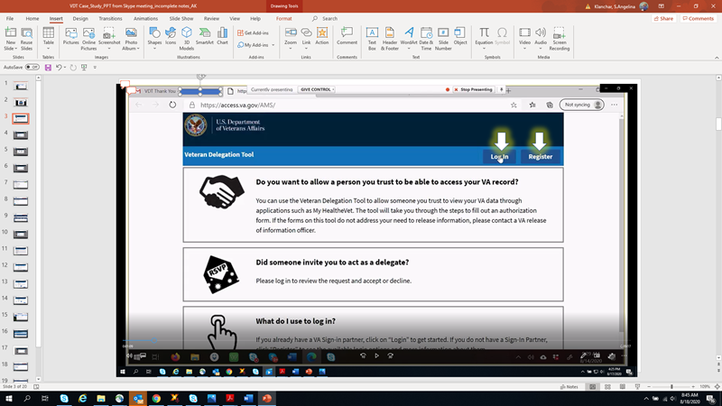

This is the first time we got to the VDT, and already stumped. Since Jacob already has a sign-in partner, wondering do we just Log-in (like that third box indicates), or do we need to register first? We went back and forth multiple times, so we can’t remember which one worked.

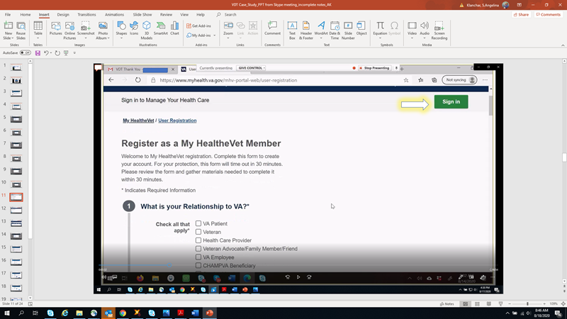

**Image 1.2**

The path seems to be going further and further away from the desired goal of signing into the VDT tool. The first pop-up had a large list of sign-in partners to choose from. We selected MHV, since the account already exists, and the end goal is revolved around MHV. Selecting sign-in, we finally got to the MHV site, but nothing indicating what to do next. Following the ‘Register as a MHV member appears to be trying to register to MHV, not to register with the tool. [*Team Response*: *this ‘loop’ only happened during the initial registration attempts... but not just with JSP*]

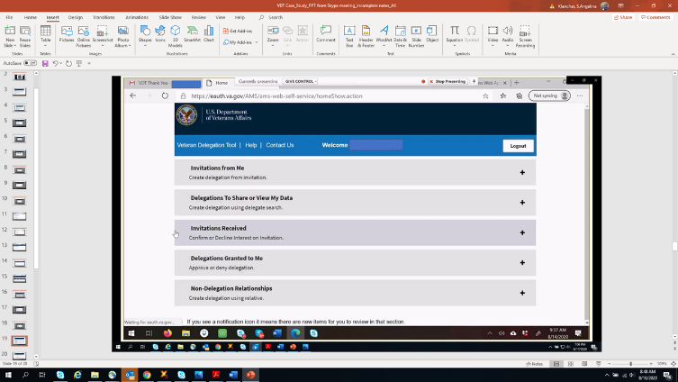

**Image 1.3**

After signing in and out multiple times, and trying a variety of combinations, we finally were able to log-in to the VDT and get started. *[Team Response: If we knew what the sign in page was supposed to look like, maybe we wouldn’t spend so much time in the wrong spots].*

**Image 1.4** Once inside the tool, it was easy to figure out where to go to start requesting delegates. [*Team Response: A few words of caution, when a Veteran and delegate have the same email- the email did not get sent (and older couples frequently share a single email account)]*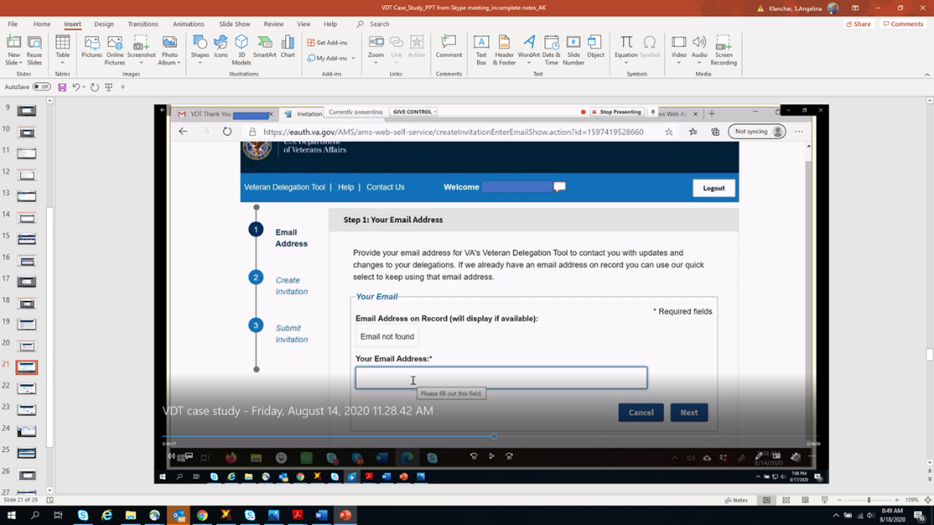

**Image 1.5**

A few days later, we received a confusing email- almost didn’t continue the process because we thought it wasn’t meant for the Veteran. The body of the letter is accurate*. [Team Response: Same issue discussed during first round].* 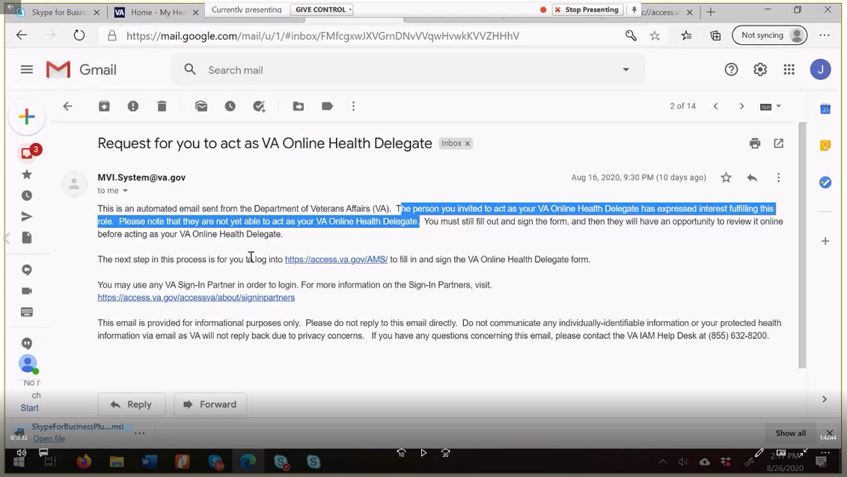



**Image 1.6**

The link quickly gets us to the right page this time, and it is easy to find which section to open, since it had a little marker indicating something was going on in there. But when we opened it- we quickly got lost again and went rummaging around the rest of the site. we weren’t trying to create MORE delegates, so that button didn’t catch our attention until we spent an hour trying every other option. Also, just want to point out- the invitation was sent 3 days earlier, but Marci (another delegation invitee) hasn’t been in front of her computer for a week! So, the invitation was expired at that point.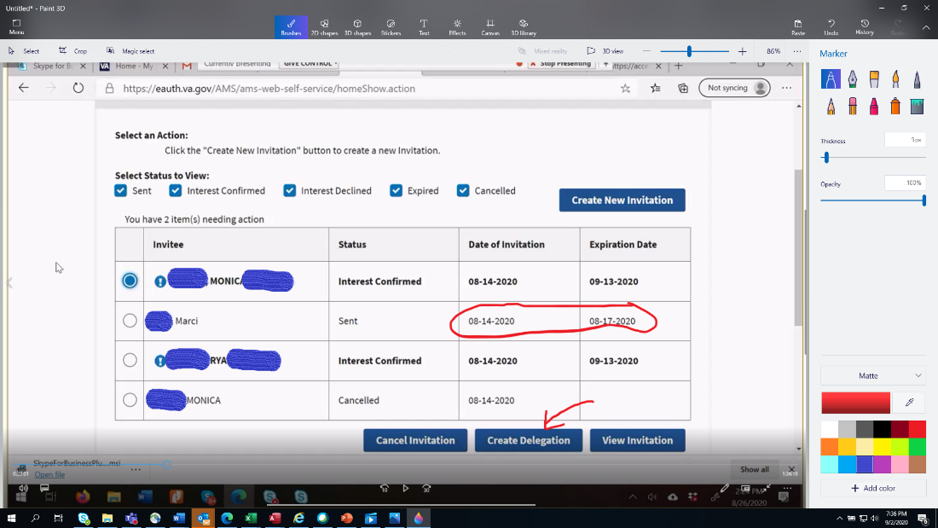

Signing the [whatever has to be signed]- Feels like you’ve completed it three times before it finally is completed – never know if it is just another rabbit hole, being done wrong, or a weird peculiarity of the VA- After 3 times, we [thought] we finally solidified having* a delegate*. [Team Response: I felt the same way- are we doing something wrong, or is it designed to make you repeat your actions multiple times? Angel’s Vignette presents this in more detail] [*in actuality, the delegate was assigned but not authorized yet].*

**Vignette #2:** Established Veteran with existing MHV and VDT (Angel) I admit it took a couple attempts to get to the home page! *https://access.va.gov/****AMS/*** Realizing that AMS must be capitalized and have a backslash after, else I landed on another webpage. **Image 2.1.** Log in was easy- it took me to the sign in partner page, logged, then immediately brought me to *my* VDT homepage. 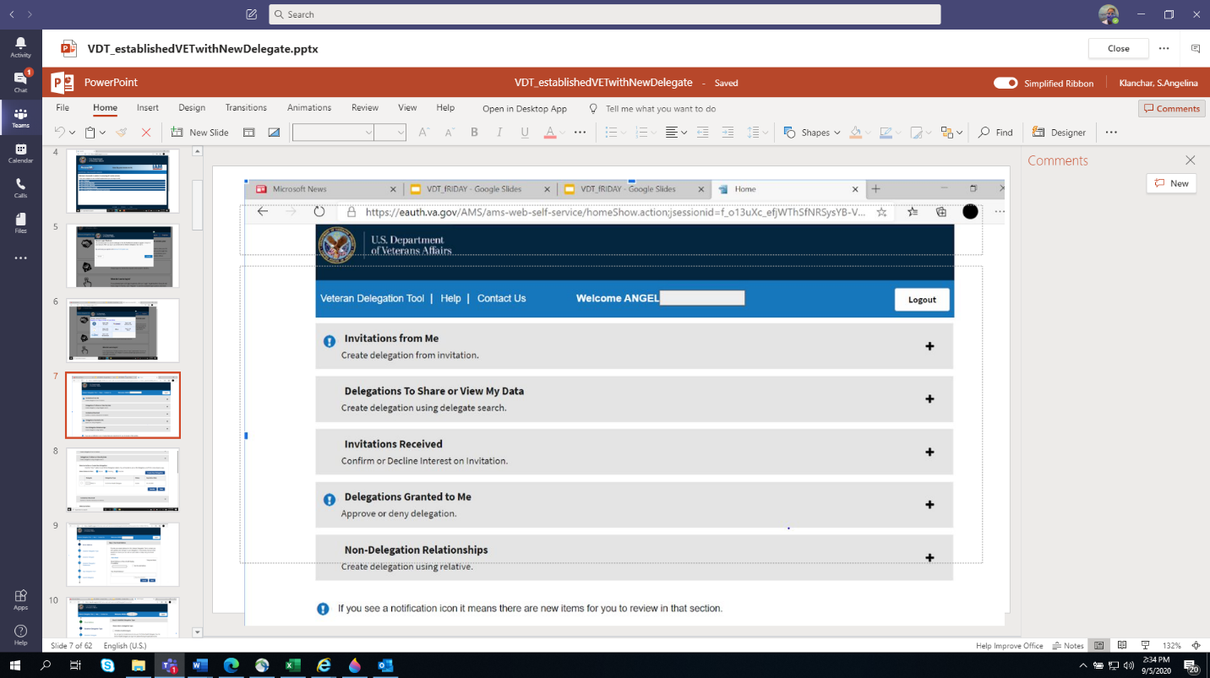

I’m not sure which one of these is the right option for sending an invitation to someone to become my delegate…

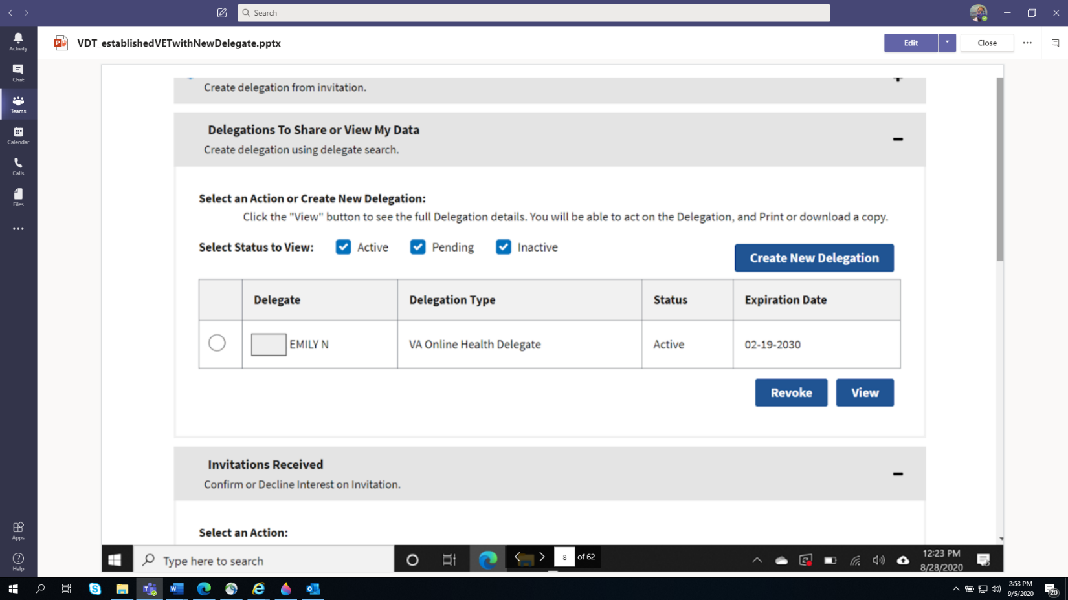



**Image 2.2** It *looks* like I selected the right one. Selected: Create New Delegate

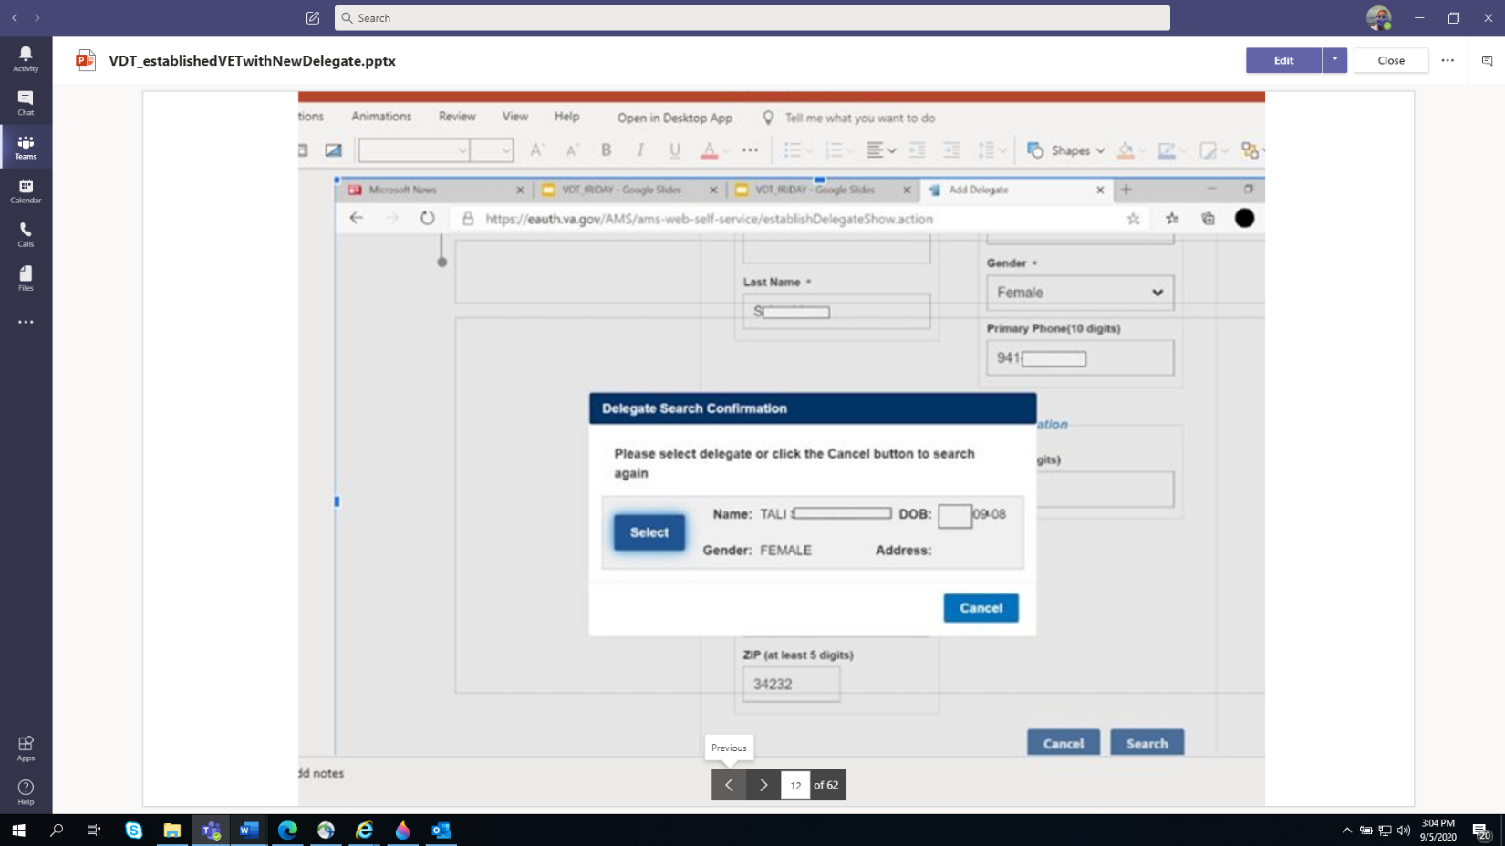

**Image 2.3.** Each time I thought I signed the form, another page cropped up, saying I still haven’t signed it. But after 3 rounds, it was officially signed.

|  |  |  |
| --- | --- | --- |

**Image 2.4.**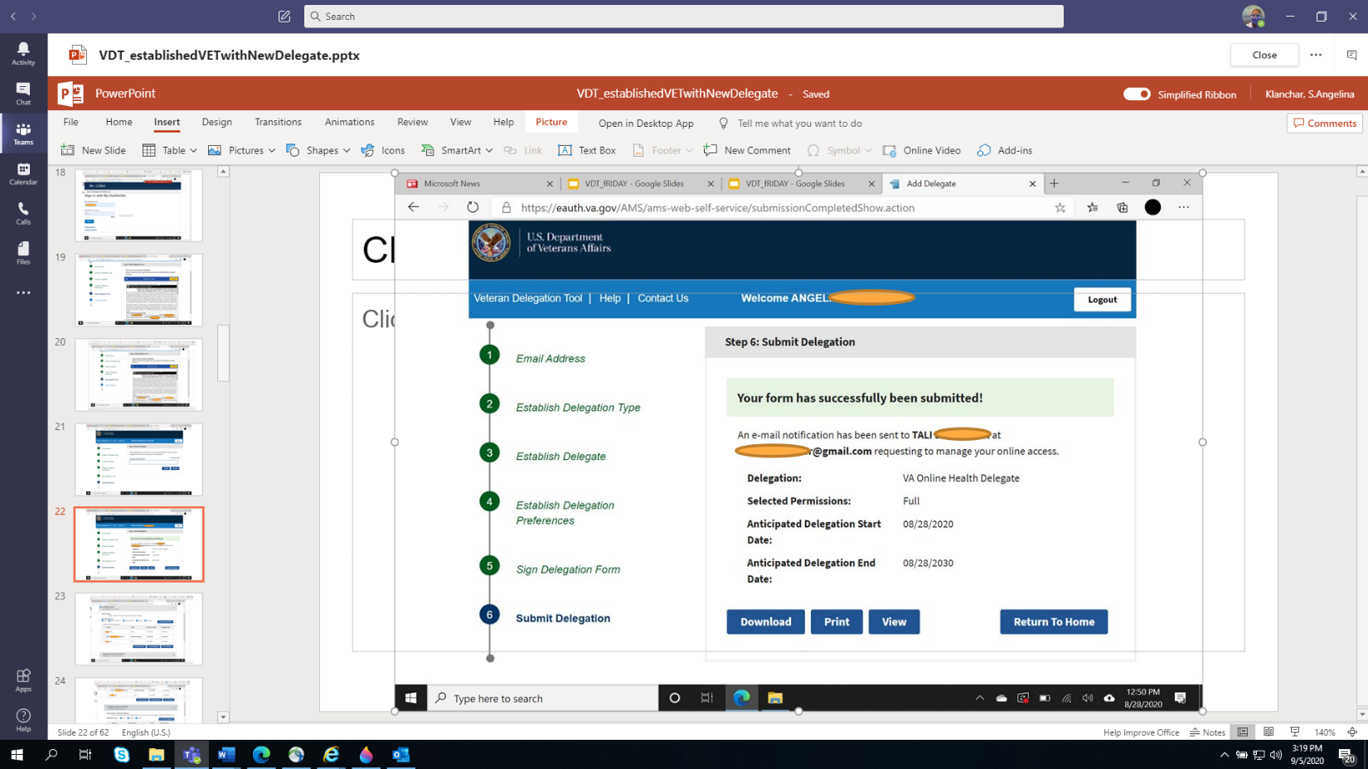

It looks like I’m done, but I noticed that that last item on the task pole on the left still hasn’t turned green (indication mission accomplished). So, I’m going back to my sign in page, to see if her name shows up in my ‘invite box’



**Image 2.5.** The good news is that I found the invitee delegate. But I still had to browse through each mailbox (?) to find confirmation of the submission. Now I just sit back and wait for her to do her part. 

**Image 2.6** When she FINALLY accepted the invitation 😉, I got this email. Since I thought SHE was going to be acting as MY delegate, this Just didn’t make any sense and I thought I did something wrong …again. But it appears to just be a misleading header.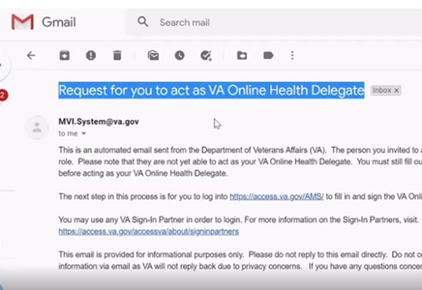

**Vignette #3** – New delegate external to the VA/civilian (Monica)

I am newly immersed into the VA healthcare realm, after an old friend fell ill and my family decided to take him in. He was receiving all his care in the civilian sector, but I remembered the stories he used to tell us, when I was a child, about his time in Viet Nam- so, I’ve been doing everything I can to get him connected to any services possible. I live out of state (in a very rural area, as you can see), so I’ve been tasked with doing all the administrative duties; things such as applying for VA healthcare, setting up appts, providing outside records to the doctors, finding resources for my brother (the ‘bedside’ caregiver), etc. Adding to the challenge, this whole process started in the middle of a pandemic. 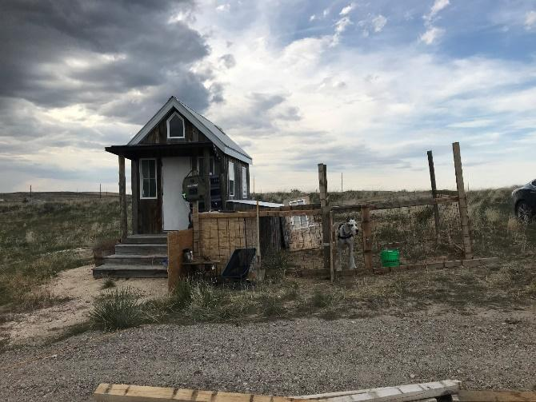

**Image 3.1**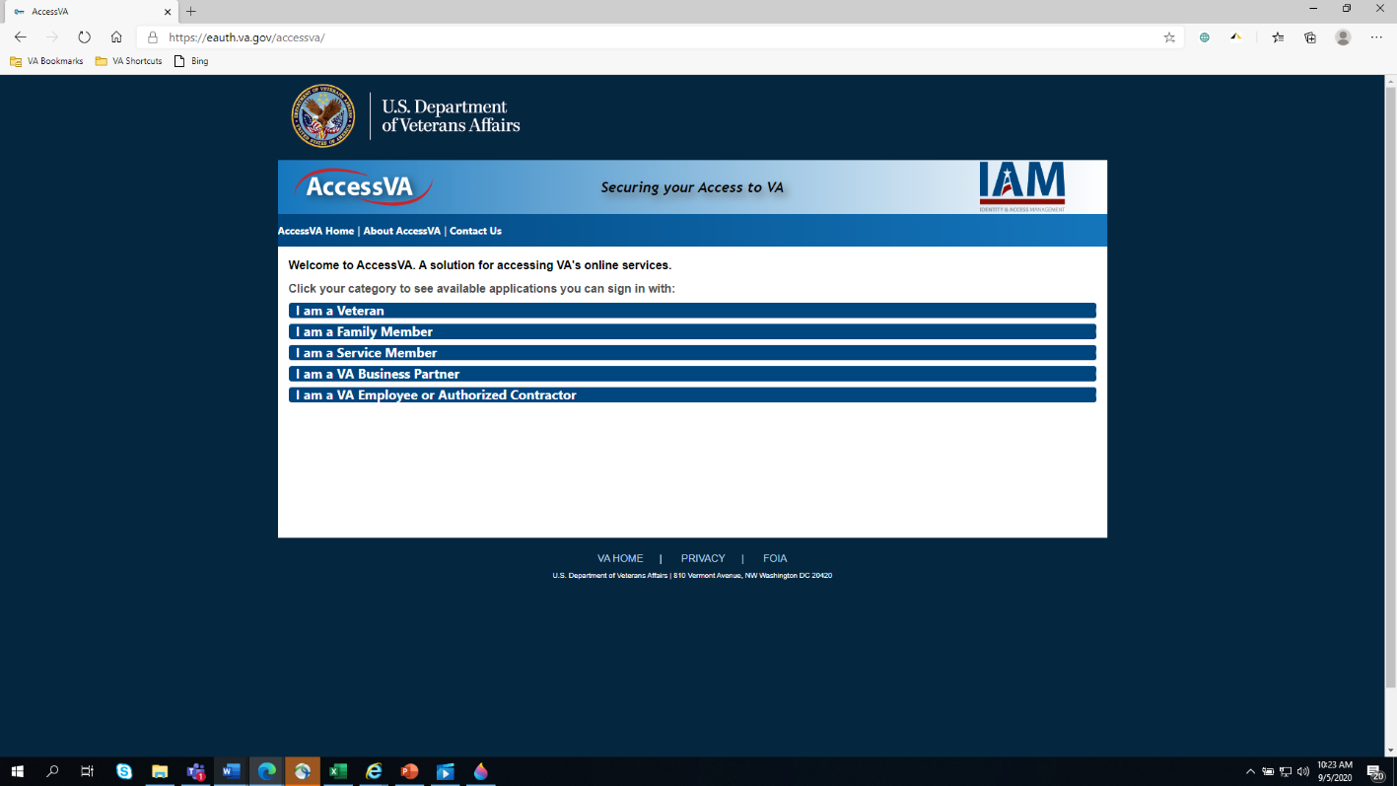

I did not have the right web browser (e.g. Edge), the first time I tried to click the link on the invitation card, so I typed it in. A lot of time was wasted following this route After 4 or 5 days, we just gave up and probably would have not made any more effort if a team member didn’t call.

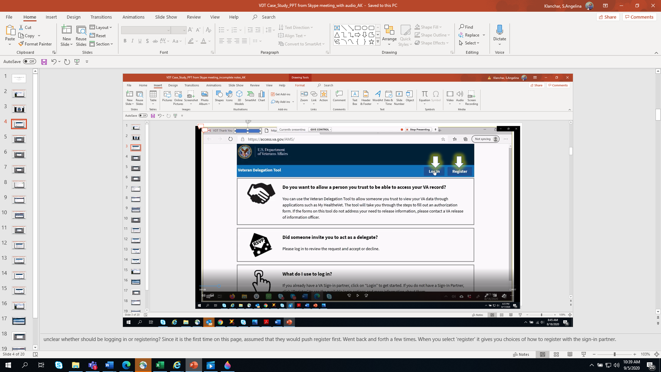

It would be helpful if we knew what the homepage is supposed to look like, so I wouldn’t have wasted so much time trying to get to it from here **Image 3.2** Also, I think it would be better if the third box was flipped with the second box of instruction. Reading from the top down, I saw that the RSVP box is specific to me- so I did what it says and chose Log-in rather than register. 

**Image 3.3.** Also, the first time I selected ‘register’ and selected MHV as my sign-in partner, It took me to the Vet’s MHV. Maybe it is because the same computer was used for the Vet to register? Or his MHV wasn’t completely logged out? IDK- but this happened the last time I tried to create my VDT account. 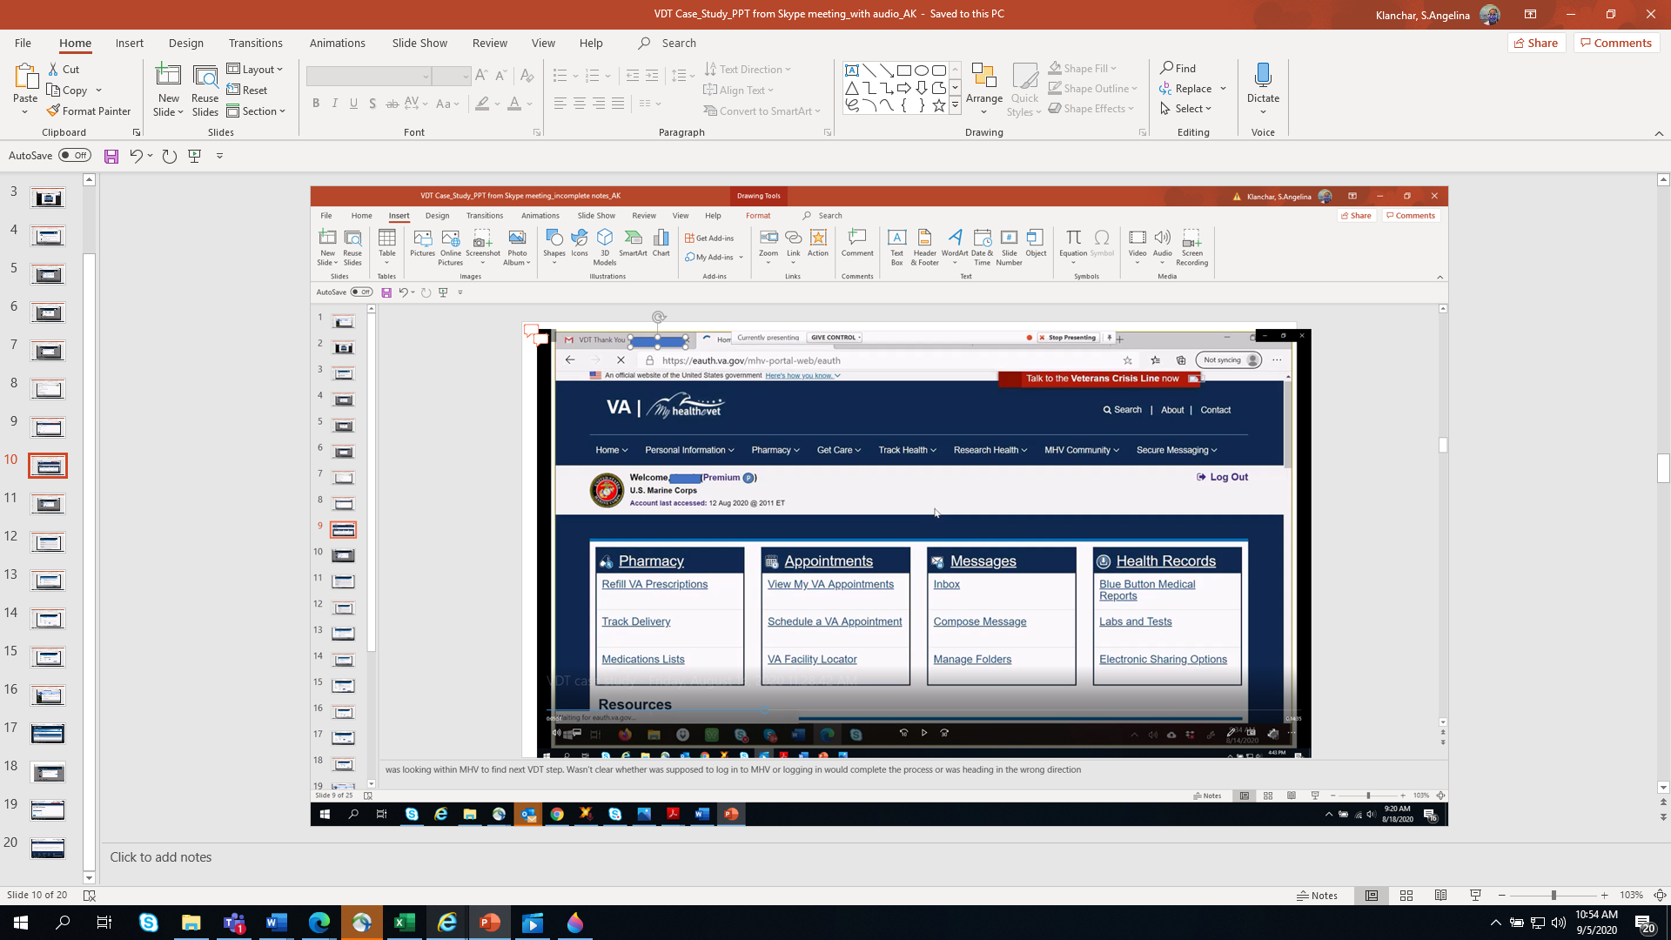

**Image 3.4.** I created my own MHV account and ID.me ahead of time in preparation for this. Made sure anybody else was logged out and started fresh. This time, when I selected to log-in with MHV as my log-in partner, I got this message. (Didn’t it say somewhere that this was going to take 10 minutes? LOL) 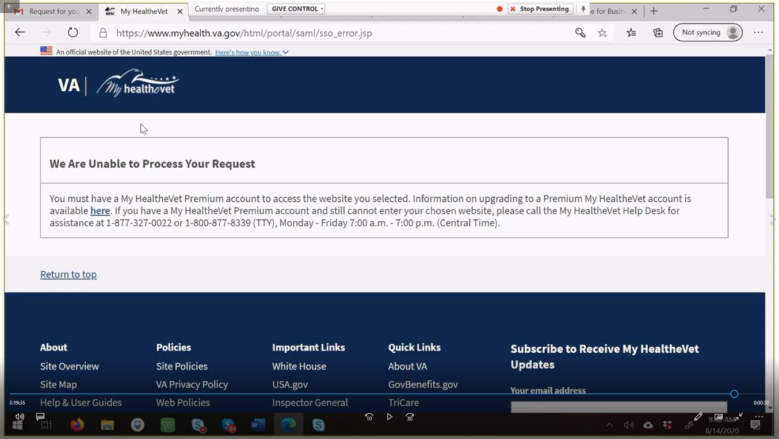

**Image 3.5.** This might not be a problem for other people, but…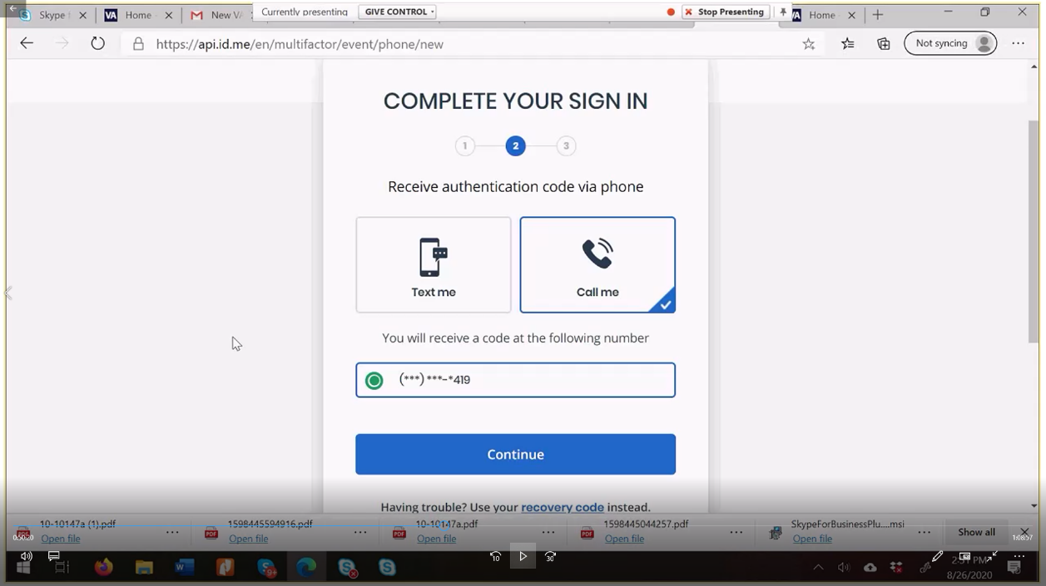

When I registered for ID.me, it would not accept two out of the three phone numbers I had. They wanted a number ‘linked to my home’ but the only phone even remotely linked to my home address was scheduled to be turned off 5 days later. There is a recovery code option, which I fortunately wrote down the first time around, but each time you log in, the code changes and I eventually missed a code change. No longer can use ID.me

**Image 3.6**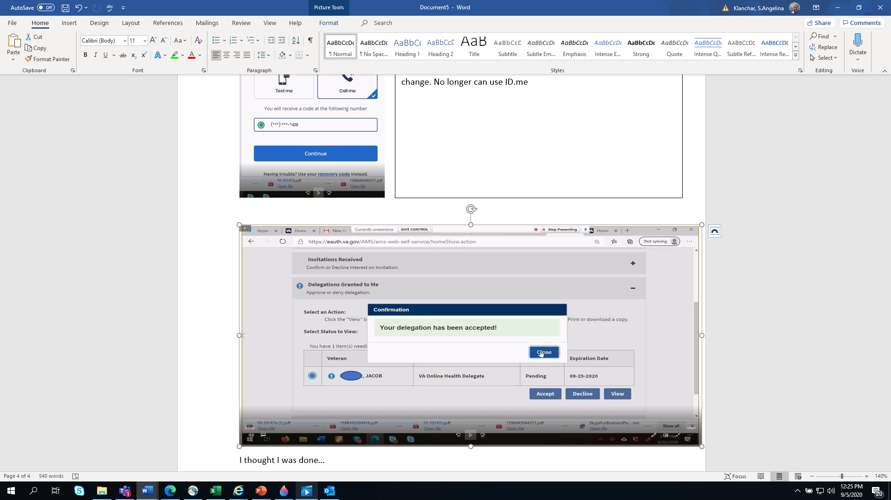

I thought I was done…

I was very happy to see that the expiration date is 10 years from now. I would be ever so pleased to be able to serve him for a ten-year tenure, if he could be with us for that long. Anyways, I didn’t realize that more still had to be done.

*[Team Response: There are instructions on the card that indicate a few more steps exist- but by this point in the process- particularly after going back in so many times trying to get it to work- it never crossed her mind to go back to the card. Instead, she trudges forward, trying to log back in to see the Vets MHV via VDT. SUGGESTION: THIS IS A GOOD PLACE TO LET THE DELEGATE KNOW WHAT TO EXPECT OR DO NEXT]*

**Image 3. 7.** I logged out of everything, then tried to log in to MHV. I initially attempted to log-in, using the MHV as a sign-in partner, but I got a message stating that “We are unable to process your request” because I have to have a “premium” MHV account, and it provided a link to do the upgrade. The problem is that the instructions in the link CLEARLY states (in several areas) that the Premium account is explicitly for Veterans and VA patients. That is why I didn’t try to upgrade to a Premium account when I created my MHV account in the first place. I then tried to sign in to MHV directly (which is an option just below the options for signing in with a ‘sign-in partner,’ but that just took me to my shell account, and I couldn’t see any of the Veterans health records.*.* I decided to go ahead and try to upgrade the account while I was in here, since it looks like it is a requirement anyways. I can figure out how to get to the Vet’s stuff later. *[Team Response: delegate would benefit from knowing how the screen would look if they are signed in as a delegate- we had this same problem before. We didn’t realize that you MUST use a sign in partner during the log-in, then it will give you the ability to choose who’s chart you are going into].*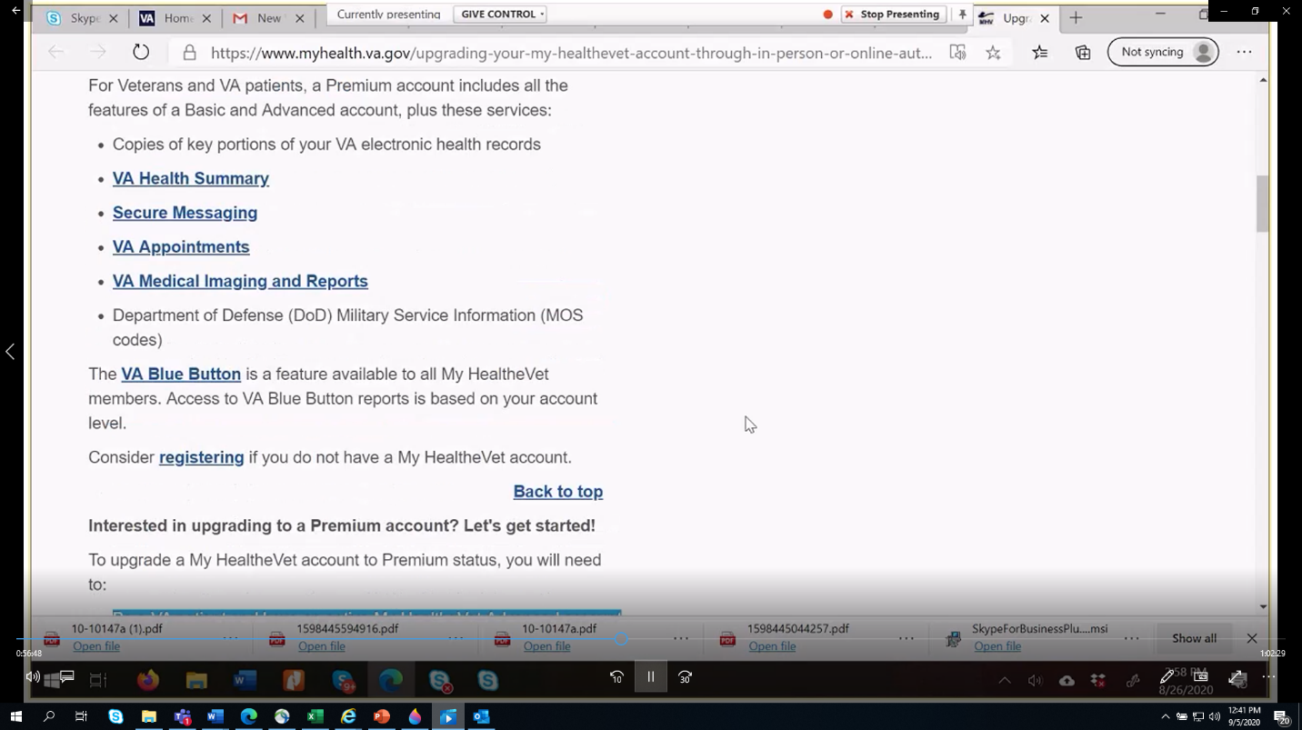

**Image 3.8.** I tried to sign in to MHV using ID.me, but I got nothing more than a polar bear in a snowstorm (tried several times and got the same result*. [Team Response: Was this because she didn’t have a premium account yet? Same thing happened with another wannabe delegate].* 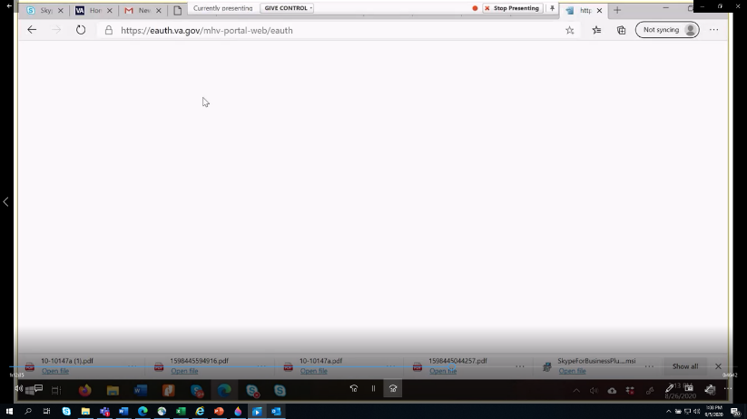

We eventually were able to get a Premium account by claiming to be a Vet/ a VA patient). However, we realized that there were additional steps that needed to be taken to complete the delegation process, after the Vet received another email. Despite this, up to this date, I have been unsuccessful in signing in, and have resorted to, out of desperation, helping him by signing into the Vet’s MHV account directly.

I hope you guys will be able to answer a few questions I have, for when this finally works

1. Can I try to reach out to the Veterans providers through my MHV account?
2. At this time, he only has one assigned provider (a specialist), so how do I reach out to the providers we are trying to establish service with? Like, I need to get him a primary care provider, a caseworker… I need to upload his civilian medical records… etc. The only provider showing up in his secure messaging, is the specialist.

**Vignette #4:** New delegate external to the VA/civilian but knowledgeable of the project (Tali)

I am part of the QI team and therefore aware of the VDT system and some of the issues related to its functionality. I tested the process with a coworker. She is a Veteran and therefore was able to send me an invite to be her delegate. We went through the process from my personal computer trying to eliminate any connection with the VA system to experience the process from a civilian standpoint. In the first step, I received an invitation email (image 4.1) with a link to accept or decline the request. The email neglected to indicate that there are multiple steps before you can actually accept/decline the request. When the link took me to a VDT page It was unclear if I needed to register or login. Per the options given (image 4.2 see middle section of the screen), the information directed me to login (I was not sure if I can login or where it would log me in). I was reading this page from the top and worked down to the one that made sense: stopping at the RSVP section, but actually the third block down made me realize that I will have to go through a registration process.

**Image 4.1.** Invitation email

​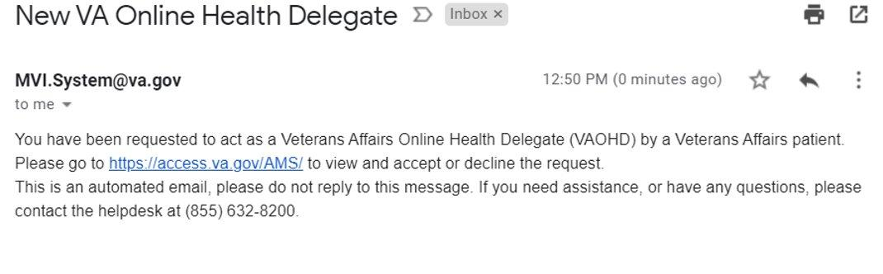

**Image 4.2**. Login/register for VDT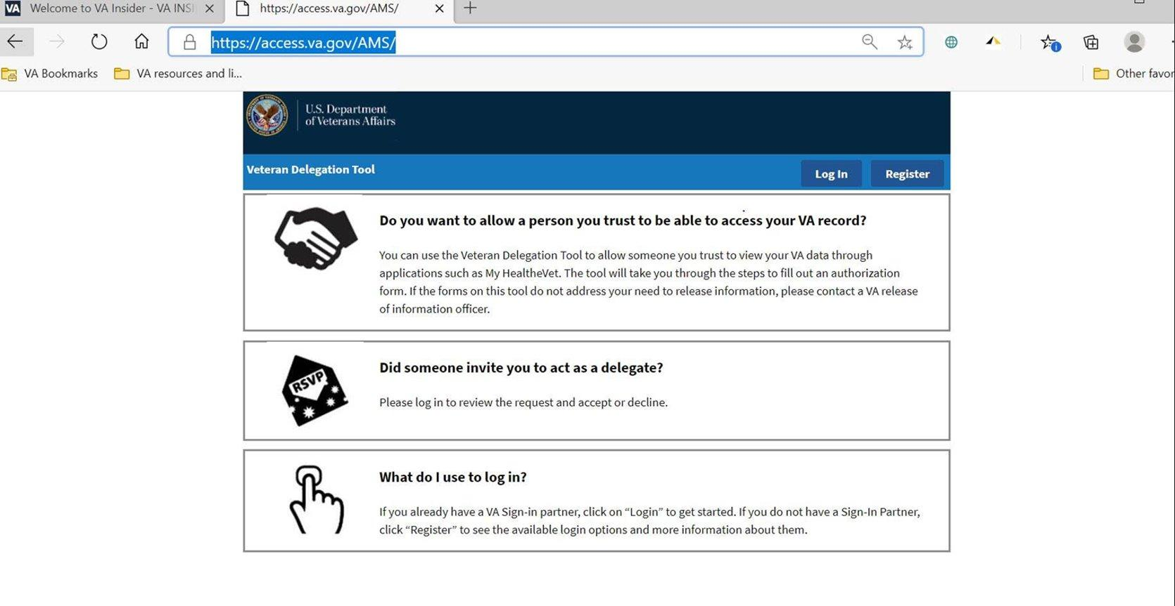

 When I chose register, I was offered 5 options to do so (image 4.3). If I were unfamiliar with the project, I wouldn’t have understood why I need to create a MHV account. I was also unfamiliar with the term sign-in partner altogether and the website does not explain the process or the different terms. I had five options to choose from of which I am familiar with 2; PIV card (however we chose to go through the process as an invitee external to the VA system) and MHV. Naturally, I would have chosen one of these two. My coworker also explained to me that the DS and the DOD CAC is for individuals in the military system, so that eliminated two of the options. Not knowing the system, I wouldn’t have known what to choose. I ended up choosing MHV as the sign-in option given my prior understanding that I need MHV in order to access the Veterans account. 

**Image 4.3**. Sign-in partners options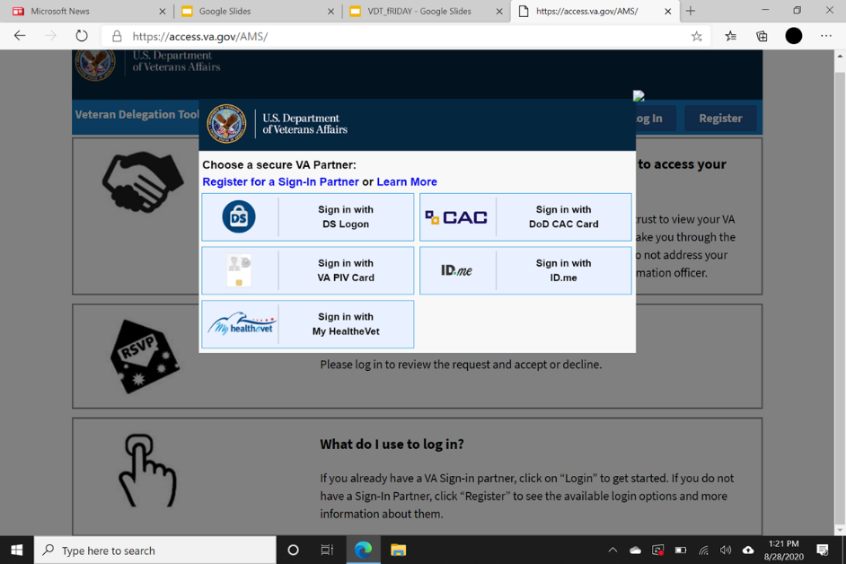

 After selecting MHV as my sign in option, the next page indicated that the process will take 10 minutes. I wasn’t sure which process would take 10 minutes: the verification of identity, accepting the invite to VDT or establishing a MHV account– obviously the whole process took a few hours… it did assure that the process is secure and will allow access to additional resources that might be relevant to other proxies. After choosing MHV as my sign-in option/button, another screen popped up saying I chose the sign-in into the VDT (this was misleading as it directed me to MHV to establish an account Image 4.4). I finally found out that I selected the wrong option (image 4.2) and cannot simply sign-in to VDT but rather need to click the register button). Starting registration, I was directed to a new sign-in page with only 3 options. Again, I selected MHV as my option. I landed in the MHV account and was asked to provide information to establish my account. Again, as a civilian, I wouldn’t have known why I needed a MHV account. When asked about relationship with VA I checked Veteran advocate (image 4.4). The registration process required me to indicate which notifications I would like to receive. I thought these referred to the Veteran I will advocate for but turned out it is for my own account as a patient that I obviously am not. 

**Image 4. 4** Registration page to MHV 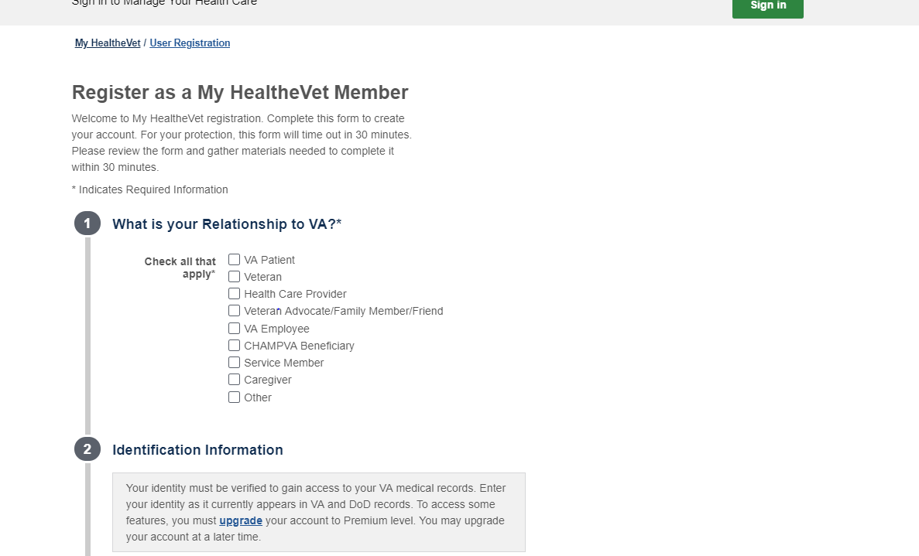

Once completing the process to have a MHV account I received a confirmation that it is my account…. But I was not directed back to accept the VDT invite. I tried the link that I received with the invite email, got back to VDT homepage, selected sign-in, chose MHV as sign-in partner and received a message I am unable to process the request (image 4.5). It appeared to me that I would need a premium account in order to be able to get the delegate status. After much searching, I found out that only Veterans or VA patients can get a premium account. As a civilian I would have stopped trying right there. However, we kept looking for more options and potentially ways to upgrade the account first to an advanced and then to a premium status, with no success. Finally, I changed my profile to a Veteran status (semi-true) and immediately my account was upgraded.

**Image 4.5.** No access to VDT without a Premium MHV account.

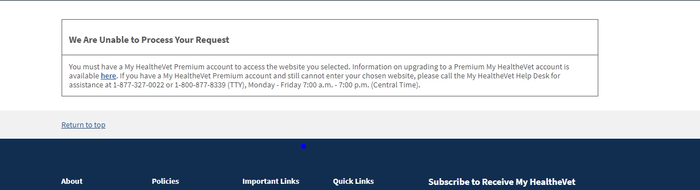

After upgrading the account, I still couldn’t see the connection to the Veteran’s information. After multiple attempts, my coworker mentioned that I will need to have an ID.me as a sign-in partner in order to review her information on MHV. So now we started an ID.me account which was promised to take 10 more minutes but took over an hour. I chose one of 4 options. For this process, new user needs to prepare identification documents: 2 primary (ID) or one primary and 2 secondary documents. I had to look for the documents, have a way to take a picture of each, upload to the system, take a selfie and, finally, have an online video chat with an ID.me staff to authenticate my identity. I believe many of the older delegates won’t have the capability to do so. Two alternative options to complete the authentication was using credit check, which I was uncomfortable with, or to authenticate in person. I finally was able to log in and linked to the VDT homepage and accept the invite (image 4.6). 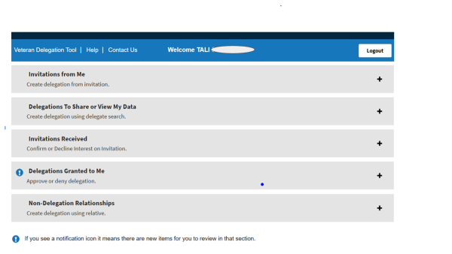

**Image 4.7.** Homepage with access to both Veteran’s and Delegate accounts. 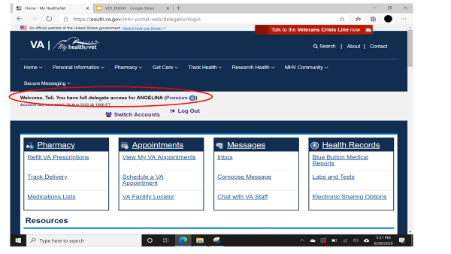

I then, logged in to the MHV account using MHV sign-in option, but couldn’t see the Veteran’s information, only mine. After multiple tries, I figured that logging in only via sign-in partner (MHV or ID.me) will link my account to the Veteran’s account (image 4.7). Once in the Veteran’s MHV account, I was able to secure message to the list of providers that appeared for the Veteran and to request medication refill. I couldn’t set an appointment unless I requested it via secure messaging. However, when providers replied to my message, I didn’t receive any notification about it. It also seems that the providers didn’t necessarily realized a delegate was writing on behalf of the Veteran. When we changed the Veterans email address to mine, I received the responses, but then the Veteran didn’t receive them. There is no option to add more than one email address. If the Veteran was sick, hospitalized or unable to access the MHV account, we wouldn’t be able to get the messages back about question, appointments, etc. Additionally, as a delegate that is not a VA patient, I have no capability to send messages from my account.

**Vignette #5:** Clinical staff end-user (Carol W)

CW receives the secure messages for her service section and is responsible for either responding or forwarding them to the appropriate provider. She received her first delegate initiated secure message in the secure messaging inbox, the message appeared to come directly from the Vet, and it never crossed her mind to also look at the message header (which shows that it was sent by the delegate- image 5.1). She responded to the message, scheduling an appt for the next day. She got another secure message from the delegate, asking more detailed questions and making it clear that the author was not the Vet but rather the delegate. This is the first time she noticed the message was from the delegate. In the confusion, she looked the delegate up in MHV- noticed that the delegate has never been seen, and quickly got mixed up with who was who, which caused even more confusion which lead her to cancel the appointment. CW received a call from the Vet while she was en-route to the schedule appt, clarifying who the two people on the SM were. In an effort to figure out what went wrong, CW went back to the SM messaging center to see what she could have done to make this work as intended. Other than paying more attention to the ‘on behalf of’ line in the SM header, there was very little CW could do to make sure the delegate was aware of the message.

**Image 5.1**. Secure Message Screen

Even though the message is from the delegate, the ONLY option provided is to send the return message to the Vet. She tried to ‘cc’ to the delegate, but that is restricted to Providers only (image 5.1). She also found the delegate had a MHV premium account but could not send a SM directly to the Delegate that way since the Delegate did not have “an established relationship” with the service. It probably would help, if the delegate included a contact phone number in the message. 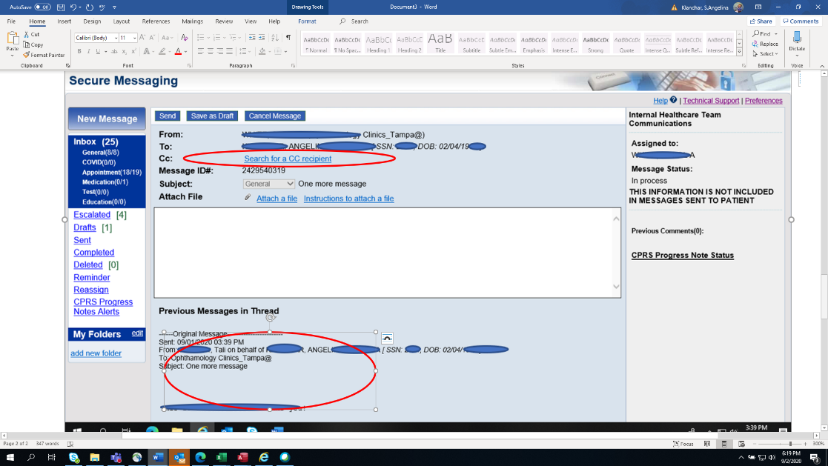

A few more comments:

* When CW forwarded the SM sent by the delegate to the appropriate provider, the link to the delegate’s name got lost, so the provider couldn’t know that the communication was done with the delegate.
* If reaching out to the delegate via phone, it is unclear how the clinical team can verify they are actually communicating with the authorized delegate.

**Vignette 6:** Administrator(Ty)

This case illustrates assistance provided to a delegate by the MHV coordinator/administrator for the VDT registration process. The referred delegate is the son of the Veteran that serves as the person who co-manages all of the Veteran’s healthcare needs on-line. The delegate attempted to register for the tool but soon contacted the delegation QI team for assistance. He stated (although not confirmed by the QI team), that he was able to register for the delegation tool, and accepted the delegation invitation, however he was unable to upgrade his MHV basic account to Premium (Exhibit 6.1). The My HealtheVet website indicates that the Premium account is only for Veterans and/ or VA Patients and it states that the upgrade can occur either online or in-person, but the caregiver is not a Veteran and has no association with the VA (Exhibit 6.2). He stated that he reached out to the MHV help desk and although the staff were helpful, they informed him that because he was not a Veteran and did not have any affiliations with the VA, he would not be able to get a Premium Account.

Image 6.1 Process Screen for Premium Upgrade

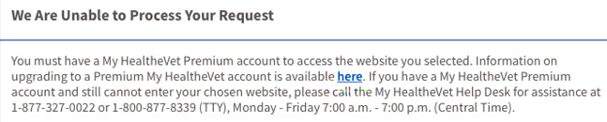

At this point, the delegate was referred to the MHV coordinator for further assistance. First, the MHV coordinator verified the identity of the delegate through video/virtual conference. He then attempted to upgrade the delegate to premium. There is a guide for upgrading veterans to premium but no current guide for non-veterans, therefore, the coordinator attempted the upgrade with the same methods used to upgrade veterans. The MHV coordinator instructed the delegate to change the setting that identified the delegate relationship with the VA to a VA patient, VA advocate, Caregiver, and Family member in an attempt to upgrade the delegate. He tried removing the labels as well as tried re-adding the labels VA patient and VA advocate, but was not successful. Therefore, the administrator was unable to upgrade the account to premium and the online delegate was unable to obtain full delegation access.

Image 6.2 How to Upgrade to Premium Account

**Interested in upgrading to a Premium account? Let's get started!**

To upgrade a My HealtheVet account to Premium status, you will need to:

* Be a VA patient and have an active My HealtheVet Advanced account
* Accept the current My HealtheVet Terms and Conditions
* Provide a primary government-issued photo ID
* Provide a secondary form of ID when your primary ID does not match your official VA medical record (such as a recent name change)

There are two ways to upgrade your My HealtheVet Advanced account to Premium. You can upgrade your My HealtheVet Advanced account online (DS Logon Premium Account and ID.me) or in person (face-to-face and video conference) at a local VA facility:

**APPENDIX B: DATA FINDINGS FOLLOW-UP INTERVIEWS** 



**VDT Use - Barriers:**

***Delegate***

* Only one delegate was able to use the tool
* Delegate was not informed if his/her inquiry was completed (e.g., appointment, medication refill). Therefore, delegate needs to log-in to check if task or SM were completed.
* The use of the tool requires computer skills. It might be too complicated for older caregivers/delegates.
* Logging-in without sign-in partner won't grant access to the Veteran’s MHV account
* Two are unable to use the tool; they either didn’t pass the ID.me authentication process or weren’t able to create a MHV premium account.

***Clinical team***

* Extra burden on doctors specifically during the COVID19 pandemic. The clinical team reports filtering messages before forwarding to the provider.

**Users Recommendations:**

* The entire process needs to be simplified
* Provide veterans with step-by- step instructions as well as a list of the documents required throughout the process. Consider a video clip that present these steps.
* In the registration phase: provide explanation for each of the sign in partners options so individuals will know which one is appropriate for them.
* While using the tool: clarify the need to sign in with the sign-in partner and which one to use in order to review the Veteran’s MHV account.
* Grant automatic MHV premium account to designated delegates.
* Notification of completed task should be sent to delegates.
* On the clinical team MHV account display
  + Add an option to look up delegates, similar to patient search.
  + Make the 'inbox' message title clear to include the name of the Veteran and delegate

**VDT Promotion and Education Recommendation:**

* Introduce VDT to the clinical team members
* Disseminate brochures to Veterans at the clinics
* Promotion strategies: market the delegation tool as granting a trusted individual to be a designated spokesperson on behalf of the Veterans when they are unavailable. Explain and emphasize the benefit of the tool to the Veterans.
* Promotional material (cards or flyers) should include large font, clear action steps, prefer not white font over dark background.